NEW PUBLICATION!

FIBIGERIANA Supplement Volume 1

A new book series to enhance taxonomical and faunistical researches of Lepidoptera

The Fibigeriana series is devoted to publish the fundamental achievements of the so-called traditional lepidopterology. One of the major aims and important missions of the Heterocera Press is to publish the taxonomically revised historical Lepidoptera collections preserved in museums. The Fibigeriana Supplement series is devoted to promote the development of the taxonomic, morphological and biogeographical research.

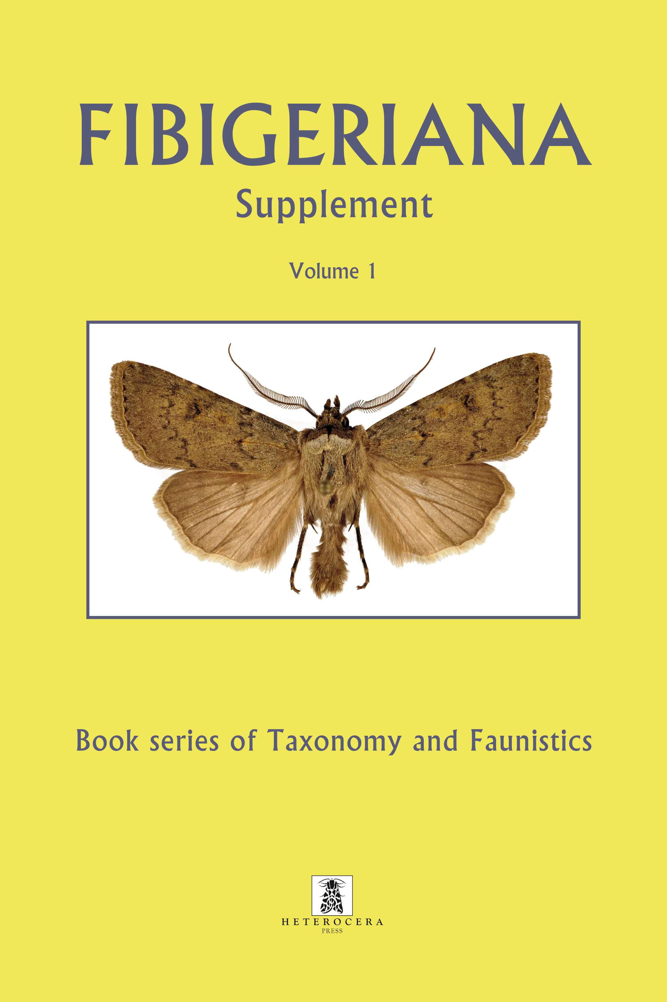

This new series is open for the amateur and professional lepidopterists to publish their new taxonomic and/or faunistical results and findings. We welcome major taxonomic revisions and monographic papers dealing with the fauna of a given area, as well as smaller analytical papers providing information about poorly known taxa and taxonomic groups, and less explored areas of our Globe.

The first volume of the Fibigeriana Supplement includes altogether 10 articles dealing with different groups of the families Noctuidae and Nolidae. The descriptions of 6 new genera, 63 new species and 1 new subspecies are illustrated by 48 colour plates in A4 size and 299 genitalia figures. The articles are focused to the fauna of eastern and south-eastern Asia, the majority of the new taxa described here occur in Burma, Cambodia, China, Indonesia (Sumatra, Sulawesi), Nepal, the Solomon Islands, Sri Lanka, Taiwan, Thailand, and Vietnam, only two of the new species live in Iran.

A special part of the volume is the first item of the Atlas of the Noctuidae Fauna of Taiwan dealing with the subfamilies Noctuinae and Plusiinae. It is a complete taxonomic revision of the species ever found in or recorded from Taiwan, with descriptions of four new species, establishment of new synonymies and taxonomic stati and with new records for the Fauna of Taiwan.

Content of FIBIGERIANA Supplement Volume 1.:

Gábor Ronkay, László Ronkay, Gyula M. László, Chien-Ming Fu & Shipher Wu: The Atlas of the Noctuidae (s. l.) Fauna of Taiwan (Lepidoptera, Noctuoidea). Part I. Noctuidae: Noctuinae and Plusiinae

Péter Gyulai, László Ronkay & Shipher Wu: Survey of the taxa of the genus Atrovirensis Kononenko, 2001 (Lepidoptera, Noctuidae, Xyleninae)

Sándor Tibor Kovács & László Ronkay: Revision of the Trachea denticulosa (Moore, 1882) species-group (Noctuidae, Xyleninae)

Tibor Csővári & László Ronkay: New Gortyna Ochsenheimer, 1816 (Noctuidae, Xyleninae, Apameini) species from eastern Asia

Péter Gyulai, László Ronkay, Gábor Ronkay & Aidas Saldaitis: New Noctuidae taxa from Asia (Lepidoptera, Noctuoidea)

Oleg Pekarsky, Marek Dvořák & Gábor Ronkay: Three new Stenoloba Staudinger, 1892 species from Southeast Asia (Lepidoptera, Noctuidae, Bryophilinae)

Gyula M. László, Gábor Ronkay & László Ronkay: Description of a new genus and two new species of the subfamily Nolinae (Lepidoptera, Noctuoidea, Nolidae)

Gyula M. László, Gábor Ronkay & László Ronkay: A new species of the genus Barnanola László, Ronkay & Witt, 2010 (Lepidoptera, Noctuoidea, Nolidae)

Gyula M. László, Gábor Ronkay & László Ronkay: Description of five new genera and five new species of Nolinae from SE Asia (Lepidoptera, Noctuoidea, Nolidae)

Gyula M. László, Gábor Ronkay & László Ronkay: Two new species of Nolinae from Sulawesi (Lepidoptera, Noctuoidea, Nolidae)

The book is warmly recommended to all professional and non-professional lepidopterists who are devoted to maintain and develop collections and are intended to study the extreme diversity of the Eurasian Lepidoptera.

Price of the book: 94,5 EUR incl. VAT (5%), (+ postal and packaging cost).

For subscribers of Witt Catalogue series -10% discount!

By subscribing the new taxonomical and faunistical book series FIBIGERIANA Supplement (the yellow series) -10% discount is given.


For subscription and ordering the new series please contact us by e-mail: info@heterocera.hu or visit our website www.heterocera.net. The book is also available at the main entomological book sellers.

